**School Management System User Story**

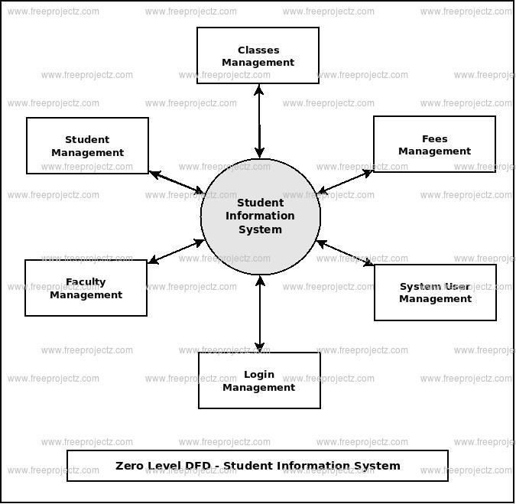

**User story for school management:**

As a user of the school management system, I want to be able to log in securely to access my account and perform various tasks related, so that I can access my role within the school community.

**User Story:**

**Login:**

As an administrator, I want to log in securely using my credentials, to access the school management system.

As a teacher, I want to log in quickly and efficiently, to access student records, update grades, and communicate with parents.

As a student, I want to log in to view my grades, assignments, and attendance records, facilitating my academic, so that I can progress continue to access my academic information.

As a parent, I want to log in securely to track my child's academic progress, attendance, and behavior reports, so that I can continue to monitor my child's academic performance.

**Fees:**

As an accountant, I want to generate invoices, receipts, and statements of fee transactions, so that I can make transparent documentation for reporting purposes.

As a parent, I want convenient access to view and pay school fees online through a secure portal, so that I can minimizing administrative struggle and facilitating timely payments.

As a student, I want to view and manage fee-related information, so that I can stay updated on payments and track financial obligations efficiently.

**Class:**

As an administrator, I want to define class schedules, including class timings, breaks, and extracurricular activities, so that I can facilitate structured learning environments and minimize disruptions.

As a teacher, I want to manage class-related information and activities, so that I can organize teaching materials, student progress within the classroom environment.

As a student, I want to view my class schedule, upcoming assignments, and academic deadlines, so that I can stay organized and manage my time effectively.

**Student management:**

As a school administrator, I want to efficiently manage student information and records, so that I can monitor student progress, facilitate communication with parents, so that I can ensure the smooth functioning of the educational institution.

As a teacher, I want access to student profiles, academic histories, and individualized learning plans, so that I can give support to student learning goals effectively.

As a student, I want to access my academic records, course schedules, and assignment deadlines online, so that I can take ownership of my learning and academic progress.

As a parent, I want access to my child's academic records, attendance reports, so that I can stay informed and involved in my child's education.